A city weekend
  - SAN FRANCISCO · A TWO-DAY GUIDE
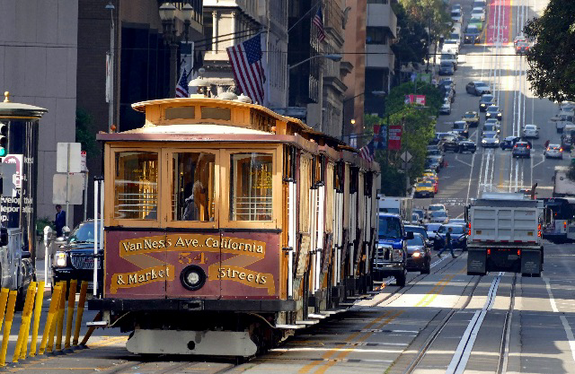
Photo: Bernard Spragg. NZ · CC0 · Wikimedia Commons

Explore at your own pace
A compact itinerary combining the waterfront, local neighborhoods and a classic cable-car ride. Keep room in the schedule to pause, take photographs and enjoy the view.
Day | Morning | Afternoon
Saturday | Waterfront walk | Cable-car ride
Sunday | Neighborhood coffee | Park and museum

Make the most of the trip

A short checklist
- Bring a light jacket for the sea breeze.
- Choose comfortable shoes for the hills.
- Check opening hours before your visit.

A little context
The cable-car system is a living part of the city. A ride offers an easy way to see familiar streets from a different perspective. This sample includes ordinary editable text, a photograph, a table and an explicit page break.

Typography check
Café · façade · 2026–2027 · 中文排版示例
Visit https://www.sfmta.com/getting-around/muni/cable-cars for current travel information.

